

**International University of Business Agriculture and Technology**

**Department:** Computer Science and Engineering

**Semester:** Summer 2023

**Course Name:** Programming in C++

**Course Code: CSC 283**

**Section: B**

**Assignment topic:** Exercise of Chapter 1, 2 & 3

**Submitted To:**

**Teacher's name:** A. S. M. Shakil Ahmed

Lecturer

Department of Computer Science and Engineering

**Submitted By:**

**Students name:** Samiul Karim Mazumder

**ID:** 22303308

Date of Submission: 25/05/2023

**Program - 01**

**Code:**

#include<iostream>

#include<iomanip>

using **namespace** std;

**int** main ()

{

**int** dis;

**float** sf,mil;

cout<<"Enter Total distance traveled(km):";

cin>>dis;

cout<<"Spent fuels(l):";

cin>>sf;

mil = dis/sf;

cout << fixed << setprecision(2);

cout<<"Bike's Mileage:"<<mil;

return 0;

}

**Output:**

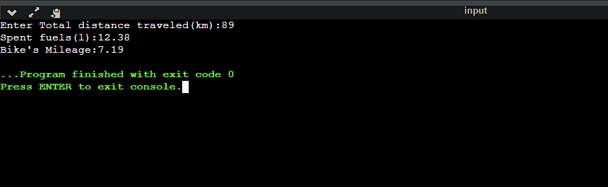

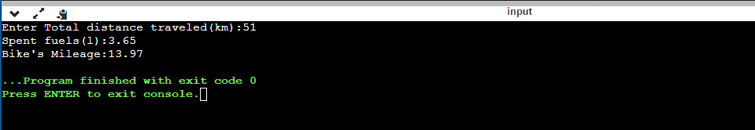

**Program - 02**

**Code:**

#include<iostream>

using **namespace** std;

**int** main ()

{

**int** m,p,c,t,add;

cout<<"Enter marks for Math, Physics and Chemistry:";

cin>>m>>p>>c;

t = m+p+c;

add = m+p;

if (m>=65 && p>=55 && c>=50)

{

if (t>=180 || add>=140)

{

cout<<"You are Eligible";

}

else

{

cout<<"You are not Eligible";

}

}

else

{

cout<<"You are not Eligible";

}

return 0;

}

**Output:**

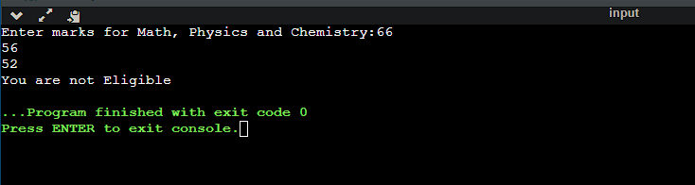

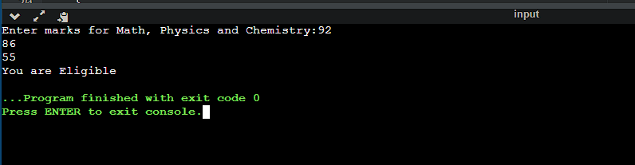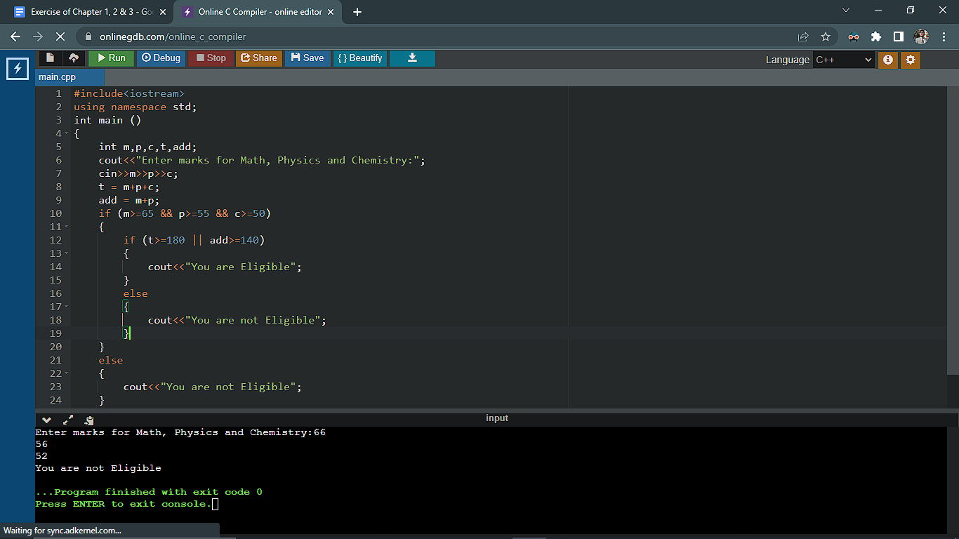

**Program - 03**

**Code:**

**#include<iostream>**

**using namespace std;**

**int main ()**

**{**

**int num;**

**cout<<"Enter a number:";**

**cin>>num;**

**switch (num > 0)**

**{**

**case true:**

**cout << "The number is positive";**

**break;**

**case false:**

**switch (num < 0)**

**{**

**case true:**

**cout << "The number is negative";**

**break;**

**case false:**

**cout << "The number is zero";**

**break;**

**}**

**break;**

**}**

**return 0;**

**}**

**Output:**

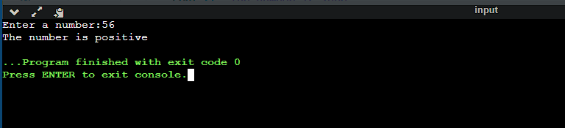

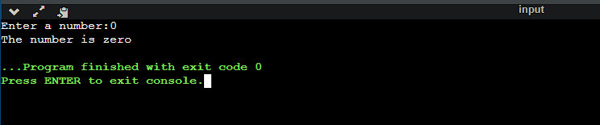

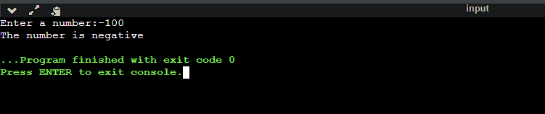

**Program - 04**

**Code:**

**#include<iostream>**

**using namespace std;**

**int main ()**

**{**

**int num,rev=0;**

**cout<<"Enter a number:";**

**cin>>num;**

**for(int i=num; i!=0; i/=10)**

**{**

**int temp = i%10;**

**rev = rev*10+temp;**

**}**

**cout<<"The reverse number is:"<<rev<<endl;**

**return 0;**

**}**

**Output:**

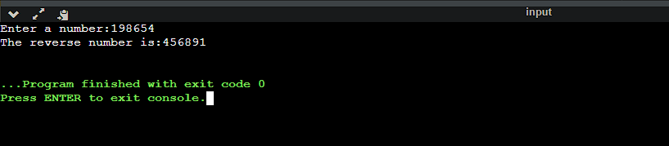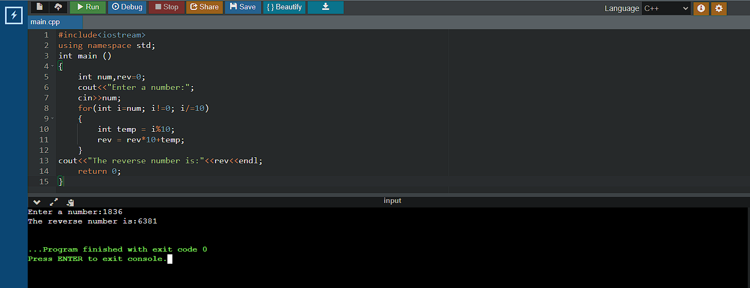

**Program - 05**

**Code:**

**#include<iostream>**

**using namespace std;**

**int main()**

**{**

**int count=0,i;**

**int x[4];**

**for ( i = 0; i < 4; i++)**

**{**

**cin>>x[i];**

**count++;**

**}**

**cout<<"Number of digits:"<<count<<endl;**

**int countNegative = 0, countEven = 0, countOdd = 0;**

**for ( i = 0; i < 4; i++)**

**{**

**if (x[i] < 0)**

**{**

**countNegative++;**

**}**

**if (x[i]%2 == 0)**

**{**

**countEven++;**

**}**

**else**

**{**

**countOdd++;**

**}**

**}**

**cout << "Total Negative numbers: " << countNegative << endl;**

**cout << "Total Even numbers: " << countEven << endl;**

**cout << "Total Odd numbers: " << countOdd << endl;**

**return 0;**

**}**

**Output:**

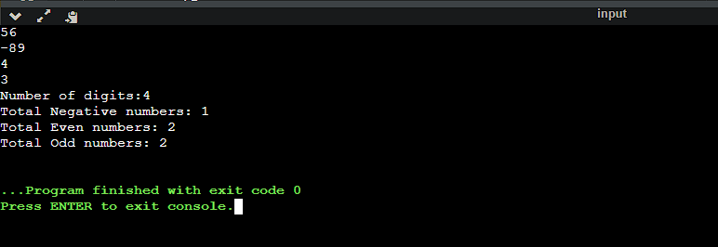

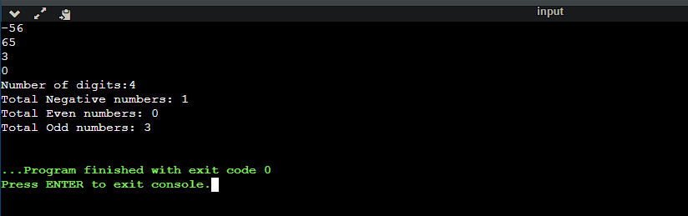

**Program - 06**

**Code:**

**#include<iostream>**

**#include<cmath>**

**using namespace std;**

**bool armstrong(int num)**

**{**

**int count=0,temp = num;**

**while (temp > 0)**

**{**

**count++;**

**temp /= 10;**

**}**

***//cout<<count<<endl;***

**temp = num;**

**int sum = 0;**

**while (temp > 0)**

**{**

**int rem = temp % 10;**

**sum += pow(rem, count);**

**temp /= 10;**

**}**

**return sum == num;**

***//cout<<sum;***

**}**

**bool prime(int num)**

**{**

**int i=2;**

**while (i <= num/2)**

**{**

**if (num%i == 0)**

**{**

**return false;**

**}**

**i++;**

**}**

**return true;**

**}**

**bool perfect(int num)**

**{**

**int i=1, sum=0;**

**while (i <= num/2)**

**{**

**if (num%i == 0)**

**{**

**sum += i;**

**}**

**i++;**

**}**

**return sum == num;**

**}**

**int main()**

**{**

**int num;**

**cin>>num;**

**if(armstrong(num))**

**{**

**cout<<num<<" is an Armstrong Number.\n";**

**}**

**else**

**{**

**cout<<num<<" is not an Armstrong Number.\n";**

**}**

**if (prime(num))**

**{**

**cout<<num<<" is a Prime number.\n";**

**}**

**else**

**{**

**cout<<num<<" is not a Prime number.\n";**

**}**

**if (perfect(num))**

**{**

**cout<<num<<" is a Perfect number.";**

**}**

**else**

**{**

**cout<<num<<" is not a Perfect number.";**

**}**

**return 0;**

**}**

**Output:**

